DECISION MEMO
SEP and MTObjects Toy-Object Masking: Results, Risks and Recommended Production Strategy
Date: 16 August 2026
Scope: Four-fold optimisation on 40 calibration galaxies and aligned eight-panel application to 182 galaxies
Decision: Select a masking strategy that balances contaminant recovery against damage to galaxy structure and bar profiles
Status: Both algorithms completed; 182/182 PNG reports available for each method
Recommendation. Use a gated two-algorithm workflow. Use SEP as the higher-recovery candidate generator, but do not accept its mask unconditionally. Automatically accept agreement between SEP and MTObjects, review or constrain SEP-only components, and fall back to MTObjects or an adaptive SEP rerun when total masked area exceeds 15% or bar-profile damage is detected. If only one unattended algorithm can be used, MTObjects is the safer scientific default; if manual review is available and recovery is the priority, use SEP with the gates below.

1. What was completed
Both methods used the same 40-galaxy fold membership: four rotations of 30 training galaxies and 10 held-out galaxies, with 40 Optuna trials per fold. Each candidate was compared on a common 40-galaxy injected evaluation set within its own run. Both selected models were then applied to all 182 galaxies to create aligned eight-panel PNG reports.
The SEP run completed on 16 August 2026 with fold 4 selected and 182/182 successful PNGs. The MTObjects recovery follow-up selected fold 3 and, after correcting the NGC3185 manifest centre, also completed 182/182 PNGs. Neither final batch contains a failed row.
Important comparability caveat: the two cross-validation runs used the same fold membership but different random injection seeds and different objective formulas. Therefore their scalar objective scores must not be compared directly. The decision below uses shared metrics (toy recall, toy detection rate and masked fraction), plus the same-size production batches.

2. Selected models
Item | SEP | MTObjects
Winning fold | 4 | 3
Detection image | Residual | Original
Detection threshold / move factor | Threshold 1.859 RMS | Move factor 0.805
Minimum area | 14 | 5
Deblending | 64 levels; contrast 0.0030 | MTObjects tree segmentation
Background | Mesh 32; filter 1 | Variance 0.000821
Dilation radius | 6 | 3
Maximum area | 5694 | 2987
Maximum elongation | 8.50 | 12.38

3. Cross-validation comparison
The four-fold held-out means summarise generalisation across all four rotations. The selected-candidate rows show each winner on its own common 40-galaxy injected evaluation set. Higher toy recall and toy detection are better; lower masked fraction is safer.
Metric | SEP | MTObjects | Interpretation
Four-fold held-out toy recall | 57.3% | 47.6% | SEP +9.7 percentage points
Four-fold held-out toy detection | 57.9% | 50.4% | SEP +7.5 percentage points
Four-fold held-out masked area | 6.6% | 7.5% | SEP lower by 0.85 points across folds
Winner common-40 toy recall | 59.9% | 50.7% | SEP higher; seeds differ between runs
Winner common-40 toy detection | 62.1% | 53.3% | SEP higher; seeds differ between runs
Winner common-40 masked area | 8.5% | 9.1% | Similar, with SEP slightly lower
Pixel precision and pixel F-score are very low for both methods under the current diagnostic definition because any mask not overlapping injected toy truth is counted as false-positive area, including masks on real foreground sources. These columns are useful for consistent optimisation within a run, but they do not estimate real-world catalogue precision and should not be the primary algorithm-selection statistic.

4. Full 182-galaxy behaviour
Production measure | SEP | MTObjects | Preferred
Successful reports | 182/182 | 182/182 | Tie
Mean masked area | 11.7% | 8.9% | MTObjects
Median masked area | 11.3% | 8.8% | MTObjects
95th percentile masked area | 20.0% | 12.7% | MTObjects
Maximum masked area | 42.0% | 19.0% | MTObjects
Galaxies above 15% | 30 | 1 | MTObjects
Galaxies above 20% | 11 | 0 | MTObjects
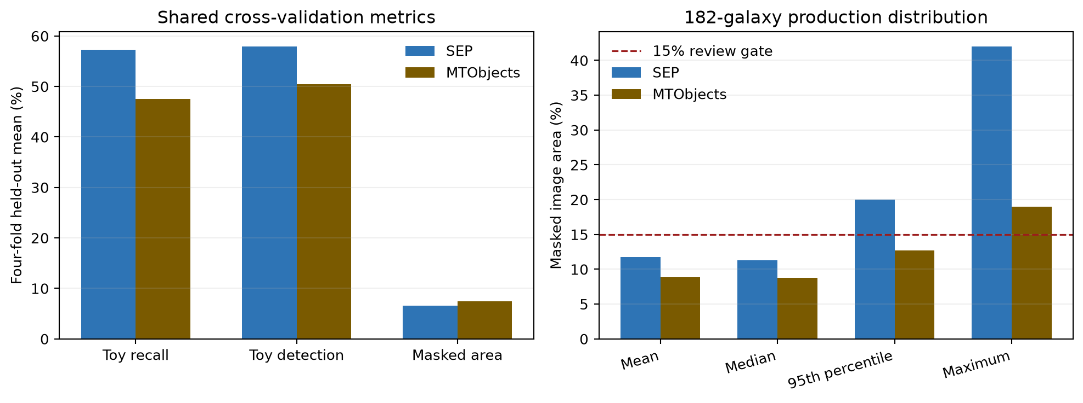
Figure 1. Shared recovery metrics and production masked-area distributions. The dashed line marks the proposed automatic review threshold.
On paired production galaxies, MTObjects masked less area than SEP in 157 of 182 cases; SEP masked less in 25. SEP exceeded MTObjects by 2.84 percentage points on average and 1.81 points at the median. SEP's most extreme case was NGC1313 at 42.0%, compared with 19.0% for MTObjects.

5. Decision and operating recommendation

5.1 Recommended production workflow: gated ensemble

Step 1: Run both methods
Generate SEP and MTObjects component masks with the selected parameters and retain component labels rather than only the final binary union.

Step 2: Accept agreement
Automatically accept components substantially overlapping in the two methods. Agreement is a practical confidence signal and should reduce SEP-only galaxy-structure detections.

Step 3: Screen SEP-only components
Accept only when they satisfy size, elongation, central exclusion and bar-proximity rules. Prefer components with a PSF-like shape or an external catalogue match.

Step 4: Enforce image-level gates
If the candidate union masks more than 15%, if a single component dominates the mask, or if the processed bar-major profile changes beyond a defined tolerance, quarantine the image for review.

Step 5: Use a conservative fallback
For quarantined galaxies, use MTObjects alone or rerun SEP with reduced dilation, increased threshold and/or a tighter maximum-area limit. Never silently release a >15% mask.

5.2 If only one algorithm can be used
Unattended scientific processing. Use MTObjects. Its lower masking tail is materially safer for preserving galaxy structure: one image exceeded 15%, compared with 30 for SEP.

Recovery-first processing with human review. Use SEP. It achieved higher held-out toy recall and detection, but every >15% image and every obvious bar/isophote disturbance must be reviewed or rerun.

6. Recommended objective-function changes
Change | Recommended implementation
Hard feasibility constraints | Reject a trial if any calibration image exceeds 15%, if toy detection falls below a minimum, or if bar-profile damage exceeds tolerance. Do not rely only on a soft mean penalty.
Worst-case or CVaR loss | Penalise the worst 10% of galaxies, or the mean of that tail, so an apparently good average cannot hide 25-42% masking outliers.
Component-level recovery | Reward the fraction of toys with a minimum overlap and use per-toy recall. Penalise false components and false component area separately, rather than allowing large real-source masks to dominate pixel precision.
Profile-preservation term | Add robust differences in the bar-major profile, isophote ellipticity/position angle and central surface-brightness gradient. Weight damage near the bar more strongly than damage far outside it.
Multi-objective optimisation | Optimise toy recovery, false-mask area and profile distortion as separate objectives and select from the Pareto front. This makes the scientific trade-off visible rather than hiding it in one arbitrary scalar.
Repeated injection seeds | Repeat each fold with several toy seeds and optimise the median plus a lower-tail recovery statistic. Current SEP and MTObjects comparisons use different evaluation seeds.
Real-foreground validation | Add a small manually annotated set of genuine stars and background galaxies. Injected toys are controlled but cannot fully represent PSF wings, diffraction features or complex background galaxies.

7. Alternative masking approaches

7.1 Catalogue- and PSF-assisted masks
For point sources, use astrometric catalogue matches (for example Gaia) and empirical PSF growth curves to define masks that expand with brightness. This can reduce confusion between compact galaxy structure and foreground stars. It should be combined with image detection for uncatalogued or extended contaminants.

7.2 Photutils segmentation
Photutils SourceFinder offers threshold detection plus multi-threshold watershed deblending, with explicit minimum-pixel, level and contrast controls. It is a useful independent implementation for an ensemble or a third benchmark, but it still needs the same toy-recovery and galaxy-damage objective.

7.3 NoiseChisel and Segment
GNU Astronomy Utilities provides a noise-based detection paradigm and a separate segmentation stage designed for diffuse astronomical signal. It is worth benchmarking where background estimation or low-surface-brightness wings defeat fixed thresholds. For this project it must be configured to protect the target galaxy, because its strength at finding diffuse signal can otherwise work against foreground-only masking.

7.4 Learned instance segmentation
Mask R-CNN and related instance-segmentation methods can jointly detect, classify and deblend sources. They are a longer-term option if sufficient labelled or realistic simulated training data can be assembled. They should not replace the current methods until tested on an external galaxy set and calibrated for uncertainty and profile preservation.

8. Immediate next actions
Priority | Action | Acceptance criterion
1 | Review SEP high-mask set | Inspect the 30 SEP reports above 15%, beginning with NGC1313, NGC1808, NGC4214, NGC3319 and NGC5236.
2 | Build component-level ensemble | Save SEP and MTObjects labelled components, compute overlap and apply agreement/SEP-only decision rules.
3 | Add release gates | Fail or quarantine outputs above 15% masked area or above a bar-profile/isophote damage tolerance.
4 | Re-optimise robustly | Use hard constraints, tail-risk loss, repeated toy seeds and a manually annotated real-contaminant validation set.
5 | Benchmark one independent method | Start with Photutils for implementation comparability; test NoiseChisel if diffuse-wing/background failures remain important.

9. Sources and audit trail
- Project SEP results: D:\Dropbox\Public Documents\UCLAN\MSc Research\Remove foreground objects\sep toy cross validation\20260816_185737
- Project SEP production summary: D:\Dropbox\Public Documents\UCLAN\MSc Research\Remove foreground objects\SEP all galaxy batch\sep_toy_cv_20260816_185737\sep_optimised_apply_summary.csv
- Project MTObjects results: D:\Dropbox\Public Documents\UCLAN\MSc Research\Remove foreground objects\mtobjects toy recovery followup\20260816_063455
- Project MTObjects production summary: D:\Dropbox\Public Documents\UCLAN\MSc Research\Remove foreground objects\mtobjects all galaxy batch\mtobjects_toy_recovery_20260816_063455_eight_panel_aligned\mtobjects_optimised_apply_summary.csv
- Holwerda, Guide to Source Extractor: D:\Dropbox\Public Documents\UCLAN\MSc Research\SourceExtractor\Guide2source_extractor.pdf
- SEP extract API documentation: https://sep.readthedocs.io/en/latest/api/sep.extract.html
- Photutils SourceFinder documentation: https://photutils.readthedocs.io/en/stable/api/photutils.segmentation.SourceFinder.html
- GNU Astronomy Utilities NoiseChisel documentation: https://www.gnu.org/software/gnuastro/manual/html_node/NoiseChisel.html
- Burke et al. (2019), Deblending and Classifying Astronomical Sources with Mask R-CNN: https://doi.org/10.1093/mnras/stz2845

